
Recruiter Toolkit
LinkedIn Messaging Template --------------------------------- 2
Intro Call Confirmation Email Template -------------------- 3
Submittal Template ---------------------------------------------- 4
Interview Confirmation Template ---------------------------- 5
Interview Prep Template --------------------------------------- 6
Interview Debrief Template ---------------------------------- 11
Identifying Fake Candidates ----------------------------------12
Thank You Note Template-------------------------------------13
Offer Letter Details --------------------------------------------- 14
Tips for New Hires ---------------------------------------------- 16
LinkedIn Messaging Template
Exclusive Full-Time Sr. AWS Engineer Opportunity- Fully Remote- Major Cyber Security Company
Hello ____,
Hope this message finds you well. I wasn't sure if you were still on the market or at least open to hearing about some opportunities that are out there right now, but I figured it was worth shooting you an email.
I am working directly with one of my clients on a AWS Engineer Role that is fully remote. Please let me know if you have some interest in discussing, as it looks like an extremely strong fit with your AWS and DevOps background.

Sr. AWS Engineer
Location: Fully Remote
Duration: Full-Time
Compensation: Market Rate

JOB SPEC:
- Must have experience as a AWS Engineer
- Must have extensive experience with AWS
- Must have experience with DevOps tools and projects
- Must have experience with Kubernetes

I hope to hear from you soon!

Please include your phone number so I can call you to discuss the role further

Intro Call Confirmation Email Template
Hi (firstName),

It was a pleasure discussing the opportunity with you. Please grant Mitchell Martin the right to represent you for the role below. In the meantime, can you please share two professional references.
Salary:
Client:
Company Website:
Location:
Attach Full Job Description:
My direct end client is looking for a Seasoned talented hands-on SDET QA Lead with experience in implementing and defining QA frameworks. The QA Lead will be working within the engineering team to ensure out and overall product excellence.
Responsibilities
- Developing QA framework for front-end and back-end applications
- Maintaining standardized, automated regression tests
- Documenting and building functional test cases
- Organizing and recording detailed test results
- Be able to maintain quality of API systems
- Contribute to systems reliability and uptime metrics
- Logging detailed and accurate defect reports and track defects to resolution
Requirements
- 10+ years of experience as a QA Professional
- 5+ years testing APIs
- 2+ years using Python or JavaScript
- TypeScript experience is a huge plus
- Strong knowledge of QA methodologies and best practices
- Strong knowledge of automated testing frameworks
- Strong understanding of software development, functional and integration testing techniques

Submittal Template
Hi (Account Executive),
Attached is the resume of (Candidate Name) for the (Role) at (Company). His/her qualifications include:

- Excellent experience as a (Job Title) for (Industry or Style of Company) Ex- major Fortune 500 companies
- Extensive experience (Actionable Responsibility for MUST have)
- Strong experience and knowledge with (Must for the Job)
- Extensive experience ((Actionable Responsibility for MUST have)
- Strong experience ((Actionable Responsibility for MUST have)
- Extensive experience (Actionable Responsibility for MUST have)
- IF CERTIFICATIONS LIST or education desired- EX- AWS Certified Solutions Architect and Docker Certified
- Excellent communication skills and available to interview immediately

NOTES:
- Visa Status:
- Location (open to Remote or open to hybrid, onsite?):
- Desired Base:
- Desired Hourly Pay Rate:
- Reason Leaving:
- Reason for Gaps:
- *If any short-term stints* Reason for Short-Term stints(Specify on each- the why)
- Interview Availability:
- Interview Activity:
- When Candidate Can Start: (Ex- 2 weeks notice)
- LinkedIn Profile ( Include URL from LinkedIn)

(Include this if Grade A Candidate)
Grade A Candidate Checklist:

MUST HAVES:

•Formatted resume that fits the job
•Tailored SOP Pitch to the role
•Salary or rate within range of bill or salary

Include all that apply- (minimum 3 needed):
•SOP Verified References collected
Include actual references Here
•Former MMI Consultant or perm placement
•Met with or video interview
•Ropes tested with good – great score
Interview Email Confirmation Template
Subject: Client Name- Mode of Interview- Confirmation: Date (Day, Date) at Time- PLEASE EMAIL ME BACK TO CONFIRM (ATTACH RESUME SENT TO CLIENT)
Hey (Candidate),
You are confirmed for your phone interview with [Client Name] on [Thursday, September 1st].
Below are the details:
Position Type: (FT or Contract)
Rate/salary confirmed: ___
Date/Time: (Thursday, September 1 at 2PM EST]
Hiring Manager: [Hiring Manager Name] https://www.linkedin.com/in/charles- panayides-S6a71911
Number Provided: [Candidates' Phone Number]
Interview Type: (Zoom, Teams, Phone, etc.)

Notes Direct from Hiring Manger for the Role:

Job Spec:

Prior to the interview, please send two managerial references with the following information provided:
Name:
Title:
Relationship:
Did you directly report to this person?
Is this person still with company?
If not do you know where they are now?
Currently working at:
Can you provide a LinkedIn for this person?
Are you sure these numbers/emails are correct?
Work Phone #:
Work Email:

Please call me directly after the interview for an interview debrief and any feedback. It is very important that we speak with you before we speak to the client.
Please confirm receipt of this email and of course reach out with any questions!
Interview Prep Template
The more prepared you are, the easier it will be for you to stand out against other candidates.
Learn as much as you can about the Company
Learn as much as you can about the company from various Internet searches. Learn what you can about their history, focus, officers/directors, locations, press releases, profitability, and size.

The Telephone Interview
In most cases a company will choose to have a brief telephone interview with a candidate before setting up a personal interview. Telephone screens offer an introduction to the firm, responsibilities of the job and technical skills needed without taking too much of either person's time. Telephone interviews can be difficult since the conversation is not backed up by personal presentation and expressions. Therefore, it is important to keep a few things in mind when preparing for the call.

Always sound alert and interested: Enthusiasm will increase your chances of being invited for an in-house interview. One of the most often received objections regarding a candidate is, “We couldn’t determine if he/she was interested or not.”
Eliminate background noise and interruptions: You will seem unprofessional or inattentive if the caller can hear your television, radio, children, computer keyboard, etc. Turn off your call waiting! Try to make your environment sound as quiet as possible to appear 100% focused on the call. In anticipation of receiving potential voice mails, it is important to have an updated, polished, professional message announcement.
Be prepared: Keep your resume, appointment book and a list of questions you have near the phone.
Give concise answers: Think of questions that might be asked and formulate your answers accordingly. Make sure to give enough detail but don't go off track.
Ask questions: Show your interest in the opportunity by asking questions that are focused on the position. Do not ask about salary or benefits. A telephone interview is not the time to discuss those issues.
Inquire about the next step: At the end of the conversation ask what the next step will be. Express your interest in further pursuing the opportunity!
Email Follow-ups: At some point in this process whether it is at this early stage or later when thank you letters are sent, it is imperative that your emails look and sound professional. Your email address should not contain any “cute” nicknames or verbiage. Though industry acronyms might be the norm, Internet abbreviations are not. With the advent of Spellcheck, there is no excuse for misspelled words!
Frequently Asked Interview Questions:
General
- Tell me about yourself.
- Why are you changing jobs; what is interesting to you about this job?
- What are your long- term professional goals?
- What do you like most about your current position? Least?
- What do you feel you can contribute to this organization?
Experience
- Describe a typical day at your office.
- What is your role within your department?
- Do you supervise or manage people? If so, to what extent?
- What is your experience with external entities? (FDA, software vendors, etc.)
- What are your technical competencies?
- How would you describe your ability to communicate technical issues to non-technical people?
- How do you prioritize projects and/or crisis situations?
Attributes
- How would you describe your abilities as a team player?
- What is your leadership style? Do you enjoy being a leader? Why? Would you prefer to not be in a leadership role? Why?
- How would you or past employers describe your personality? (Initiative, enthusiasm, stability, consistency, etc.)
- How would you or past employers describe your work habits? (Address issues promptly, met deadlines, provide accurate paperwork, etc.)
- How do you perform under pressure?
- What do you like to do outside of work?
- Be prepared for hypothetical questions where you will be asked to explain what you would do given a certain situation. These types of questions address how you respond to situations in a short amount of time. They also attest to the extent of your business knowledge.
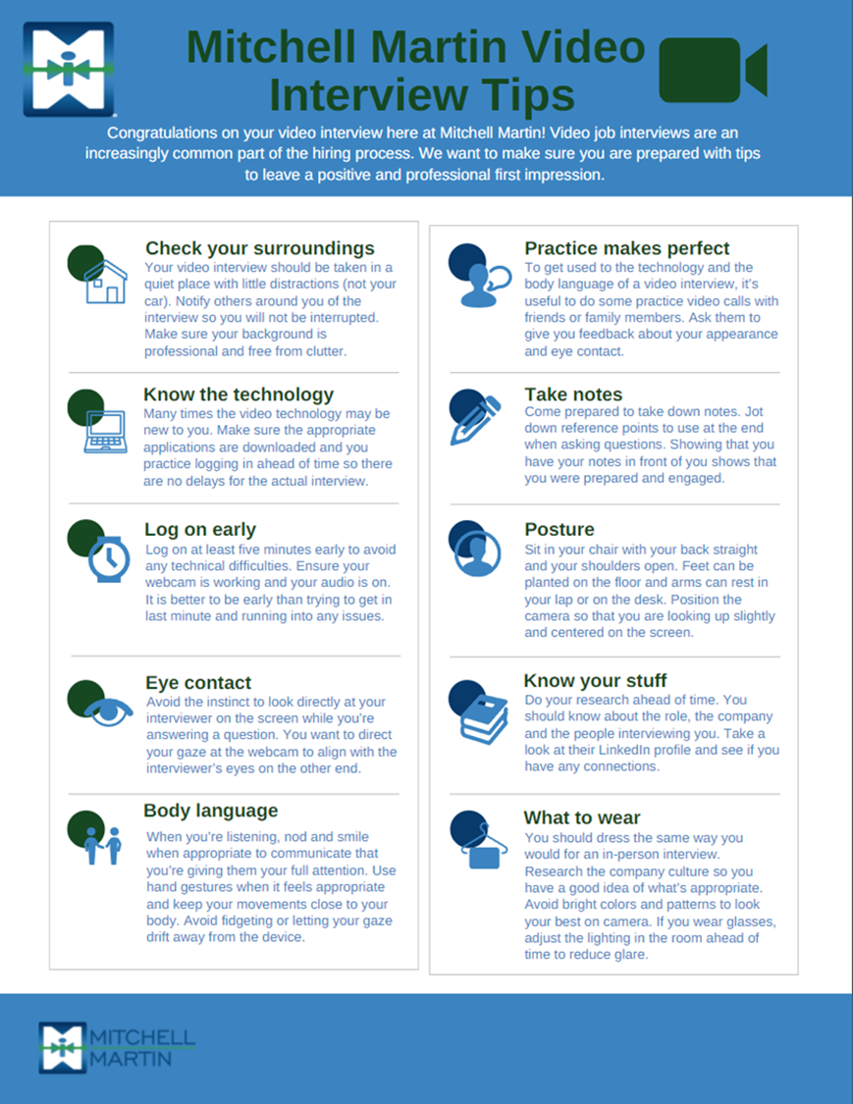

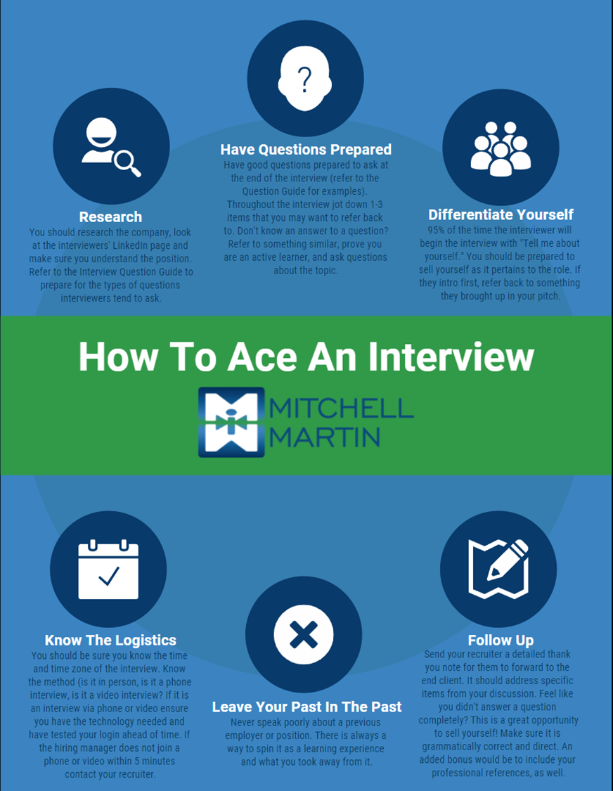

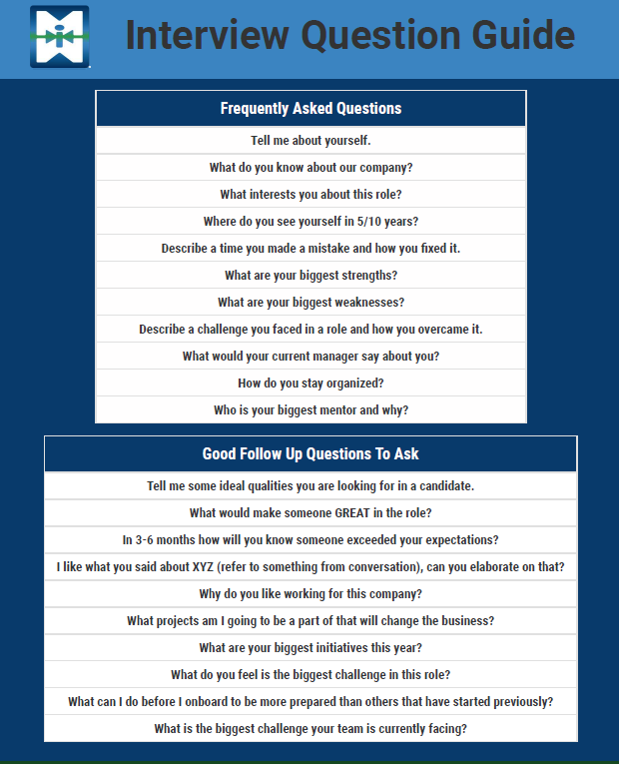

Interview Debrief/Pre-Closing Template

- How did the interview go? How do you feel you did personally?

- How long did the interview last?

- Was the prep I gave you helpful for this interview? What else do you wish you would have known?

- What specific questions did they ask you and what were your responses?

- Was there anything they asked you that you had difficulty answering or could not answer?

- What did you do well on? What was easy for you to answer?

- Who did you interview with? What was their role?

- Were there any next steps discussed?

- Are you still interested in this role after your interview?

- Is this still a top priority, second, third? Why?

- Where does this compare to other roles you are interviewing for? Get specifics on other roles (how many, which round for each/do they have other offers, their preference, rates).

- If offered the position, would you accept? Can I accept on your behalf?

- When can you start, should you get the offer and accept?

- For FTE Candidates- Have you thought about getting a counteroffer? Would you consider taking the counteroffer?

- If you accept, will you be ending your interview process?

- Availability to interview the rest of the week:
Identifying Fake Candidates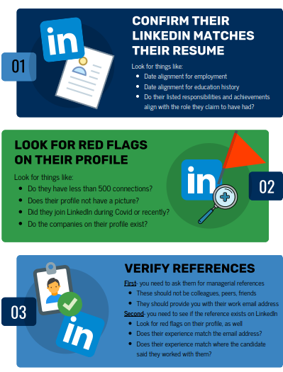
Thank You Note Template
(Hiring Manager),
Thank you for taking the time to speak with me today. It was great getting to know you. I really enjoyed our conversation about the (Position Title) role and appreciated learning more about working with (Position’s Team).

It sounds like a rewarding role, especially given the opportunities for leadership, collaboration, and advancement. It was interesting learning more (discuss responsibilities for the job) I am excited to meet the team and assist in any capacity.

I believe (discuss qualifications/certifications) will make me an excellent candidate for this role.

I look forward to the next step in the hiring process. Feel free to reach out if you have any further questions.

Thanks,
(Candidate Name)

NOTE: This is a great template to give your candidates an idea of how to write their thank you note. Make sure they are putting it into their own words to differentiate themselves!
Offer Letter Details
Template 1: W-2 Candidates
Congratulation on your offer with __________
Tentative Start: 2-3 weeks once background check clears
Location:
Duration:
Rate:
Could you please share the following details to generate the official offer letter? Thank you.

Your Legal Full Name:
Your Mailing Address:
Mobile Phone:
Social Security Number:
Visa Status:
Visa Expiration
Date of Birth:

2 Professional Supervisory References:
Name:
Title:
Company:
Email:
Phone:

Template #2: For C2C Candidates
Congratulation on your offer with __________
Tentative Start: 2-3 weeks once background check clears
Location:
Duration:
Rate:
Could you please share the following details to generate the official offer letter? Thank you.

Candidate’s Legal Full Name:
Candidate’s Mailing Address:
Candidate’s Mobile Phone:
Social Security Number:
Visa Status:
Visa Expiration
Date of Birth:
Name of C2C:
C2C EIN Number:
Signer’s Name:
Signers Email Address:
Company’s Address

2 Professional Supervisory References:
Name:
Title:
Company:
Email:
Phone:

Template #3: Fulltime Offers
Your Legal Full Name:
Your Mailing Address:
Mobile Phone:
Email Address:
Start Date:

Tips for New Hires
Just some general feedback/advice on the folks that we put in rotation, especially the ones that want to go into sales:

Coaching opportunities:
- Build a rapport with the Salespeople. That means getting them on the phone and chatting with them about things other than the job order. Build that relationship.
- Overcommunicate with the Salespeople. “Imagine they are selling to potential hiring manager” Would they just send resume and say, “what do you think?”
- Be assertive with Sales; if they are not calling you back or responding, call and call again, leave a voicemail, or put time on their calendar. This is good practice for selling.
- SELL the candidates- what makes them a good fit?
- In general, even though it’s internal, approach every situation as if they were selling to a hiring manager.



